<https://pdfs.semanticscholar.org/b5d5/ba0652078dcf7540c538b92218d33145dbc1.pdf> -

In the first step background image is calculated and subtracted from all the images to get the foreground images. In these images only moving people are left in the frames. Optimization of the threshold value to specify which pixel belongs to background and which pixel belongs to foreground plays an important role in segmenting the moving people in the mattaf area and to filter out the jitter or small movement of the video camera. In the next stage, blobs of particular size are identified to estimate the number of people in the crowd. In this step, proper selection of blob size is very important as larger blob size may combine two or more people together and show them as single person, whereas smaller blob size may consider a single person as two or more persons. After identifying the blobs of a particular size, these blobs are counted and we output the number of people present in the frame as the count of the blobs present in this frame.

For blob detection, image is first converted to binary image. Then next step is finding the connected components in the binary image. To find the connected components in the binary image, we start with the unlabeled pixel and find the neighboring connecting pixels and label them connected. We keep doing it until there is no neighbor. Then we search from the next unlabeled pixel and repeat the same process

<https://www.researchgate.net/publication/236292403_Real-time_Crowd_Monitoring_using_Infrared_Thermal_Video_Sequences> -

Thermographic images represent the electromagnetic radiation of an object in the far infrared range, which is 6 − 15µm. The principle of Thermography is based on the physical phenomenon that any body of a temperature above absolute zero (-273.15 °C) emits electromagnetic radiation.

[here](https://lepton.flir.com/application-notes/people-finding-with-a-lepton/)

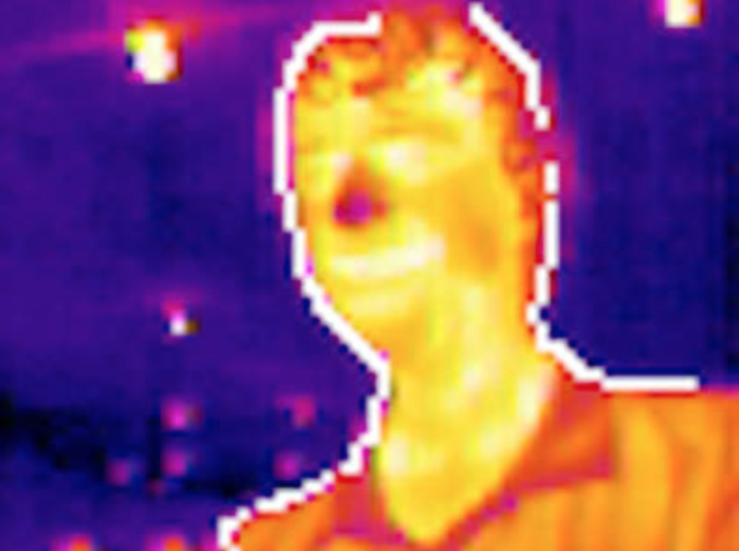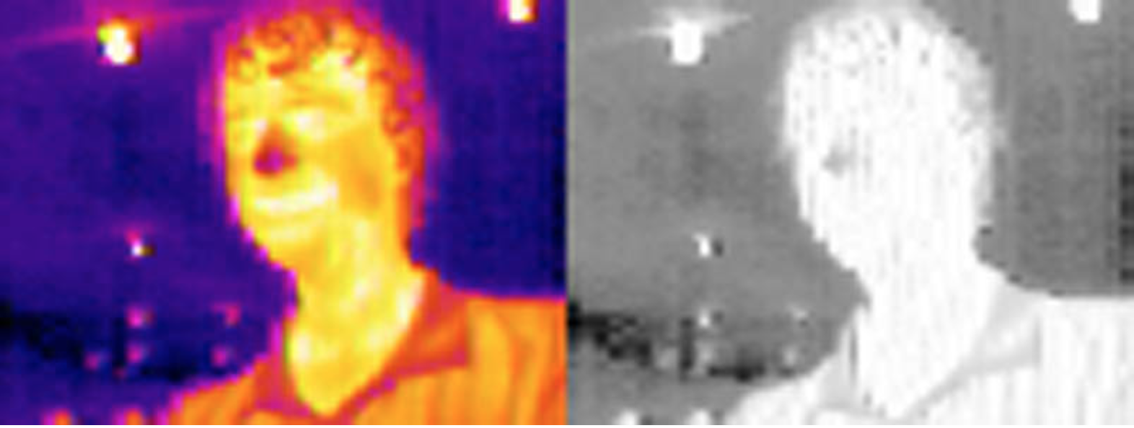FLIR Lepton has a guide on using OpenCV to detect people with the Lepton 2, found [here](https://lepton.flir.com/application-notes/people-finding-with-a-lepton/). The FLIR guide focuses upon detecting a person up close, rather than a group of people. Initially, the thermal image is converted to HSV as people tend to show up brightly and have a high V value.

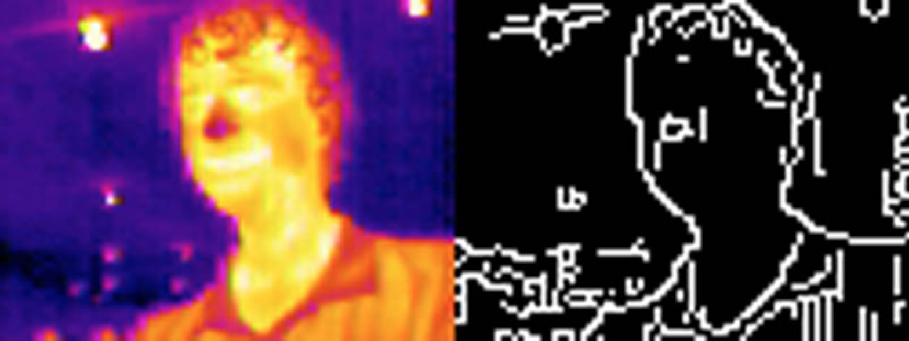 Next, a Canny filter is used to detect the edges of the person, however, this is prone to noise in the image from lights and other high frequency noise.

A bilateral filter is used to reduce the noise. The bilateral filter replaces the intensity of each pixel with a weighted average of intensity of nearby pixels. This filter helps to preserve edges, leaving the outline of the person relatively unaffected.

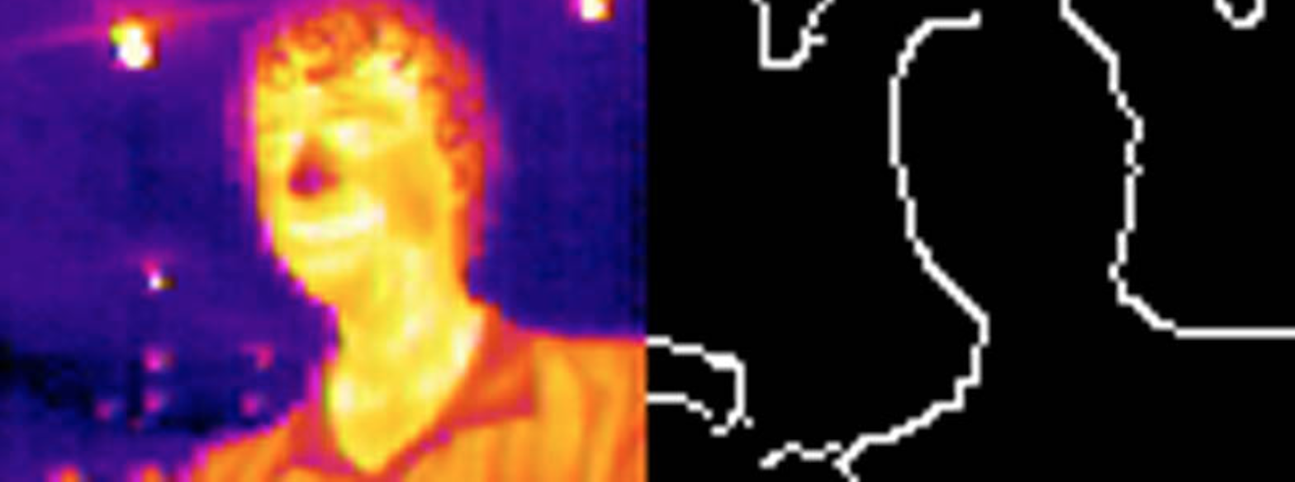 Once this is completed, there is often still some noise left in the image due to lights. This was removed by thresholding the initial image to put a 1 where the image is bright, and 0 otherwise. Next, the image blobs are eroded, making them smaller, before being dilatated back to the same size. All small blobs, usually indicative of lights, will be eroded away and will not have any values to be dilatated back to regular size. This will keep the largest blobs, usually people, however it may not preserve the outline.

**OpenCV People Counter**

<https://www.pyimagesearch.com/2018/08/13/opencv-people-counter/>

When we apply object detection we are determining *where* in an image/frame an object is. An object detector is also typically more computationally expensive, and therefore slower, than an object tracking algorithm. Examples of object detection algorithms include Haar cascades, HOG + Linear SVM, and deep learning-based object detectors such as Faster R-CNNs, YOLO, and Single Shot Detectors (SSDs).

* **Phase 1 — Detecting:** During the detection phase we are running our computationally more expensive object tracker to (1) detect if new objects have entered our view, and (2) see if we can find objects that were “lost” during the tracking phase. For each detected object we create or update an object tracker with the new bounding box coordinates. Since our object detector is more computationally expensive we only run this phase once every *N* frames.

**Automated people-counting by using low-resolution infrared and visual cameras**

<https://pdfs.semanticscholar.org/1911/42ae4e22b078a7ea817a8c0887529617084d.pdf>

used thermal cameras in conjunction with visual cameras. Reduced the error rate down to 3%.

Method:  
thresholding – admitted this would go wrong when the crowd density is high, and that further processing would be required.

Neural Networking.

**Developed product already**

<https://evolveplus.com.au/solutions/people-counters/overhead-thermal-counters>

**Room occupancy measurement using low-resolution infrared cameras**

<https://www.researchgate.net/publication/224195975_Room_occupancy_measurement_using_low-resolution_infrared_cameras>

use a 16x16 thermal camera

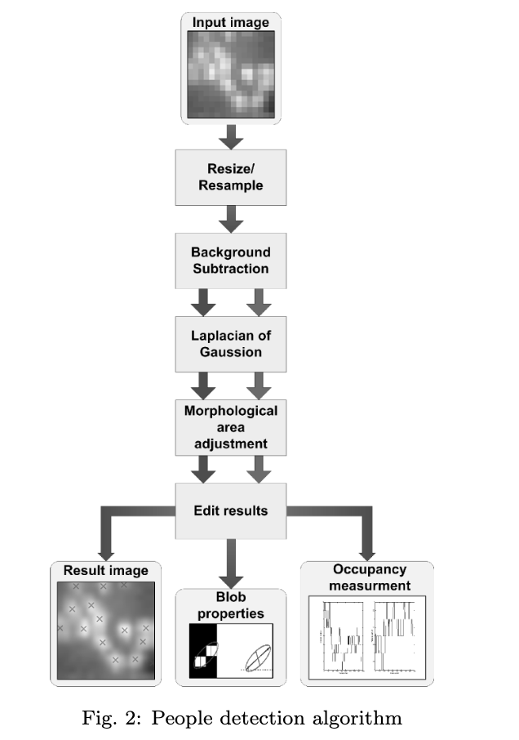  
Method:

* Rescaling. Increases size and quality of image using “bicubic interpolation”. (extension of linear interpolation)
* Background subtraction – Take an average of a few frames to help remove noise to better identify areas of interest. In an scenario where object free backgrounds are not obtainable,
* Laplacian of Gaussian blob detection method - <https://stackoverflow.com/questions/14982206/scale-space-blob-detection-using-opencv> found that this method was very prone to adjustments in the height and angle of the camera.
* Area adjustment

**Camera Footage**

<https://www.google.com/url?sa=i&source=images&cd=&cad=rja&uact=8&ved=2ahUKEwig3diqkKnhAhVCcCsKHdmzDaMQjRx6BAgBEAU&url=https%3A%2F%2Fgfycat.com%2Fdefensiverashamericanratsnake-vmas2017-mtv&psig=AOvVaw0tMHJeof9jmFnp7b2BRGNz&ust=1554009861074925>

<https://www.google.com/url?sa=i&source=images&cd=&cad=rja&uact=8&ved=2ahUKEwid1rK5kKnhAhVbfH0KHQTHAJkQjRx6BAgBEAU&url=https%3A%2F%2Fwww.researchgate.net%2Fpublication%2F236292403_Real-time_Crowd_Monitoring_using_Infrared_Thermal_Video_Sequences&psig=AOvVaw0tMHJeof9jmFnp7b2BRGNz&ust=1554009861074925>

<https://www.google.com/url?sa=i&source=images&cd=&ved=2ahUKEwj98KHOkKnhAhXLTX0KHTLlBpoQjRx6BAgBEAQ&url=http%3A%2F%2Ffree-journal.umm.ac.id%2Ffiles%2Ffile%2F015_8123am0803_133_140.pdf&psig=AOvVaw0tMHJeof9jmFnp7b2BRGNz&ust=1554009861074925>

<https://www.google.com/url?sa=i&source=images&cd=&cad=rja&uact=8&ved=2ahUKEwiYnL_okKnhAhVZbysKHWQfCFwQjRx6BAgBEAU&url=https%3A%2F%2Fwww.rsipvision.com%2Fpeople-counting-with-infrared-camera%2F&psig=AOvVaw1VTaA7pZDsjL-E7Obo8PQI&ust=1554010074321199>

<https://www.google.com/url?sa=i&source=images&cd=&ved=2ahUKEwjr9_T2kKnhAhXbdn0KHe65DJMQjRx6BAgBEAU&url=https%3A%2F%2Feps.utk.edu%2Fresearch%2Ffacilities_remote.php&psig=AOvVaw1VTaA7pZDsjL-E7Obo8PQI&ust=1554010074321199>

<https://www.google.com/url?sa=i&source=images&cd=&cad=rja&uact=8&ved=2ahUKEwid1YWOkanhAhXJXisKHf3kCUMQjRx6BAgBEAU&url=https%3A%2F%2Fmemeburn.com%2F2014%2F08%2Fare-thermal-cameras-the-key-to-halting-africas-ebola-spread%2F&psig=AOvVaw1VTaA7pZDsjL-E7Obo8PQI&ust=1554010074321199>